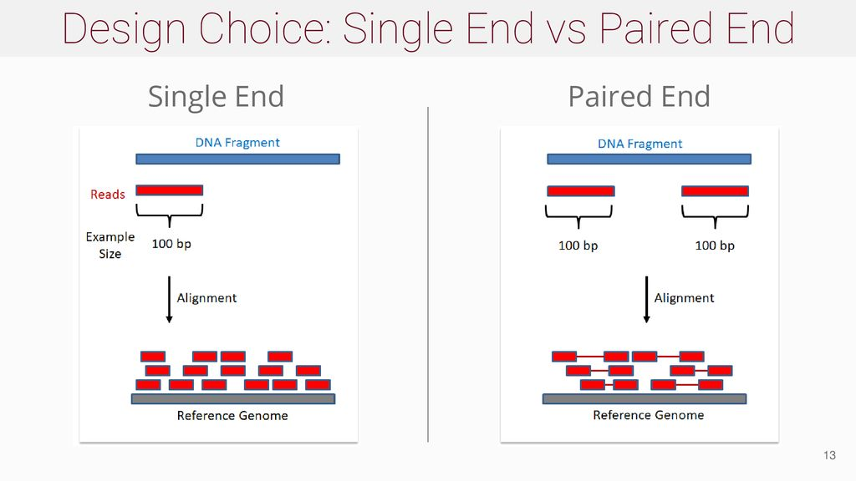
- Xem kỹ sam file (bằng lệnh samtools view) sau khi mapping với bwa mem cho paired-end sequence thì thấy một số reads ko có đủ thông tin mapping của cả pair hoặc có read ko được map ở đầu nào cả. Có những read map nhiều hơn hai lần

- Note lại một vài định nghĩa, lặp đi lặp lại cho nhớ:
- Each sequencing run generates a number of total reads
- Number of reads/ sample = number of total reads / number of samples
- Number of reads for one sample = library size
- Sequence coverage: describes a relation between sequence reads and a reference
- Sequence depth: describes a total read number

Định nghĩa về coverage và depth trong bài báo “Sequencing depth and coverage: key considerations in genomic analyses”, tuy nhiên khá nhiều variance.
Actual empirical per-base coverage represents the exact number of times that a base in the reference is covered by a high-quality aligned read from a given sequencing experiment.

Redundancy of coverage is also called the depth or the depth of coverage
Một vài thông tin khác:
Real-world sequencing approaches: read lengths are short (<250, năm 2014) and can contain sequence errors

Những từ dùng thay thế hoặc đã cũ: point source = sharp peak, broad source = broad peak, mixed source = mixed shape

Saturation in number of peaks identification

High numbers of reads are required to identify all possible peaks. Peaks that are newly discovered as the number of reads increases tend to show a lower average enrichment relative to the control sample, which suggests that they mark either more weakly bound sites79,80 or sites where a lower proportion of histones are modified

Paired-end sequencing is preferred over singleend sequencing, as it allows improved identification of duplicated reads and a better estimation of the fragment size distribution, and it also increases the efficiency of mapping to repeat regions. [*]

Từ bài trên, [*] dẫn đến bài “Systematic evaluation of factors influencing ChIP–seq fidelity.”

